1. Install OpenJDK 8

To properly use JFrog Artifactory, you will need Java installed. Download the Java 8 Development Kit. We can download official Oracle JDK or else we can install using openjdk.

I’m installing using OpenJDK.

Commands:

1. sudo apt update 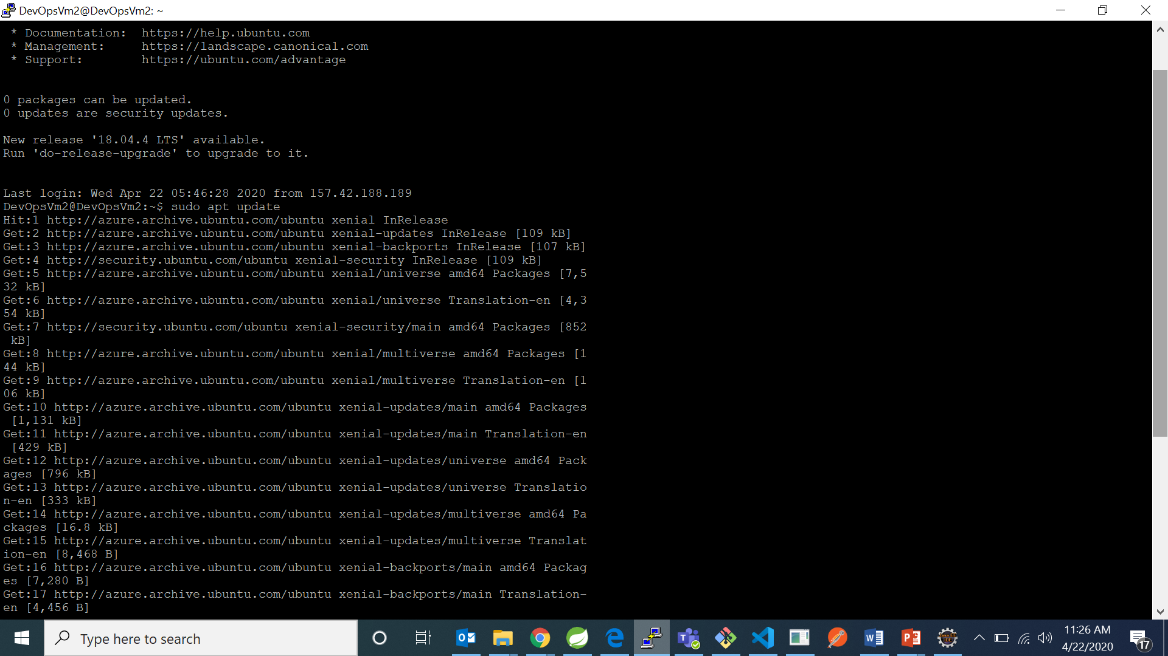
2. sudo apt-get install openjdk-8-jdk

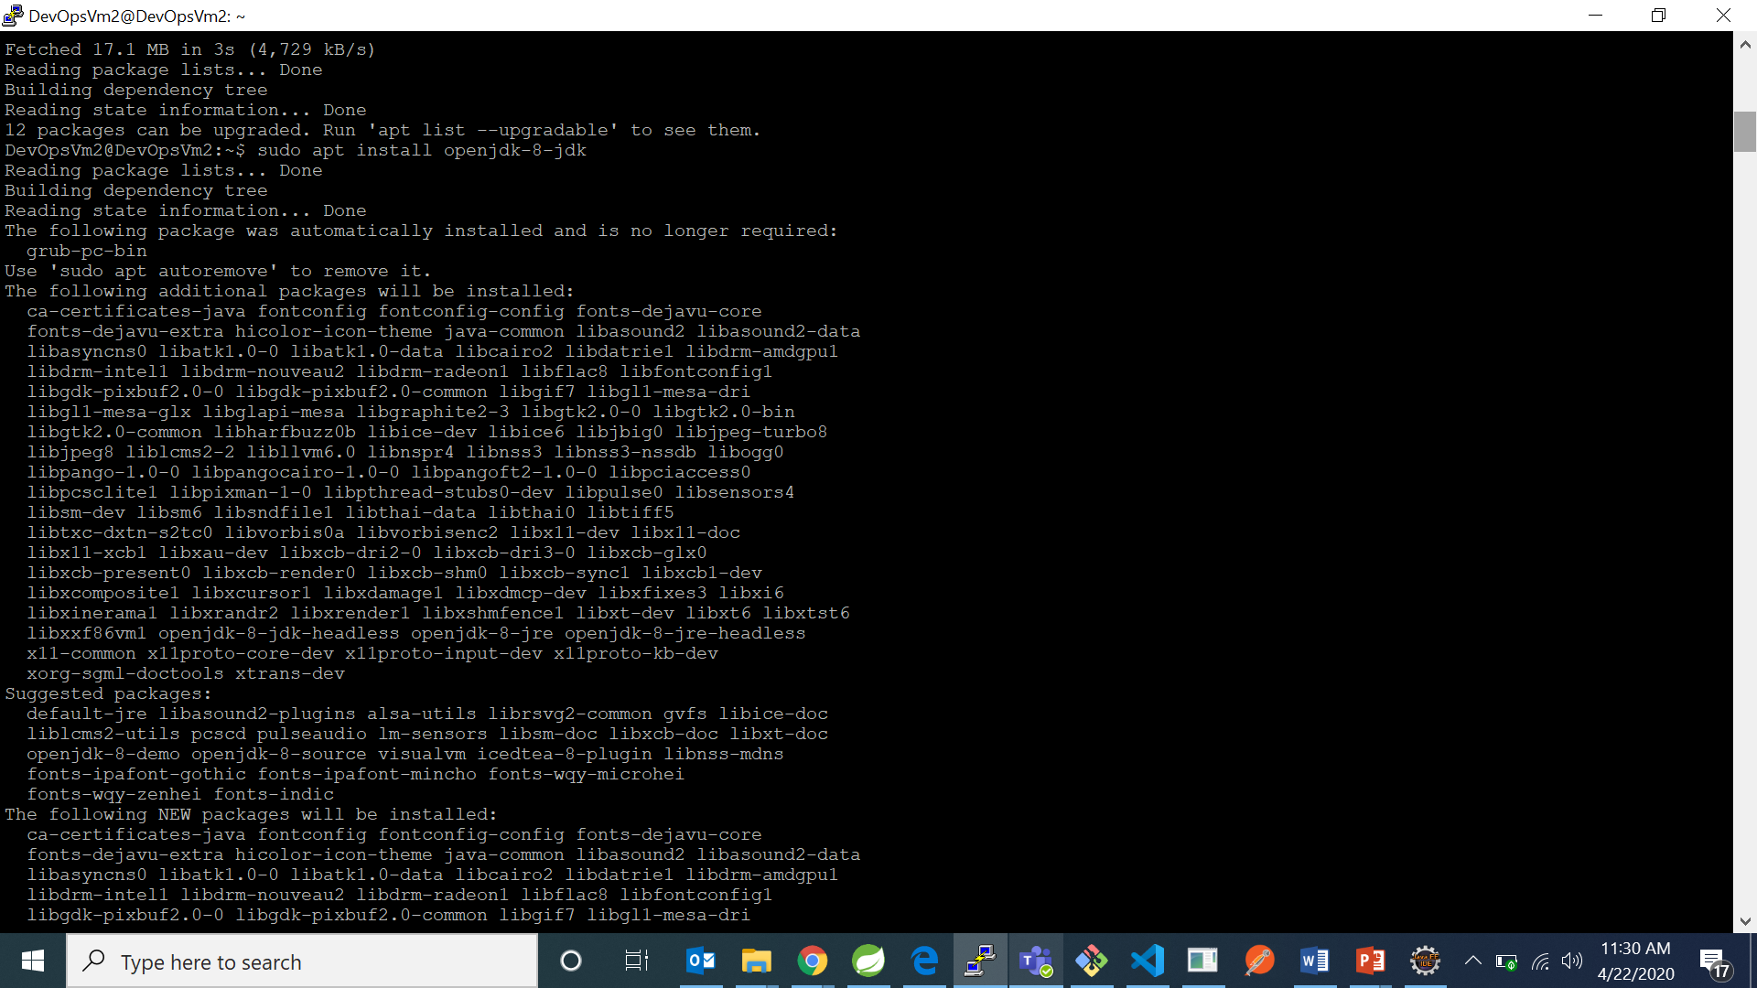

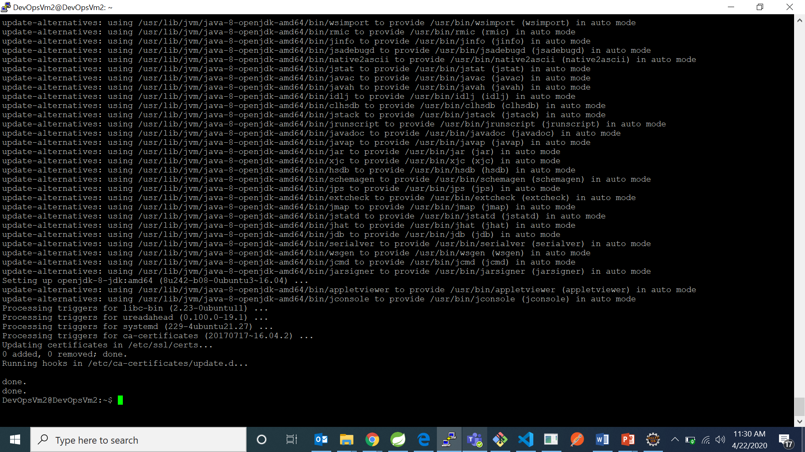

1. Now check for java version using : “java –version” command

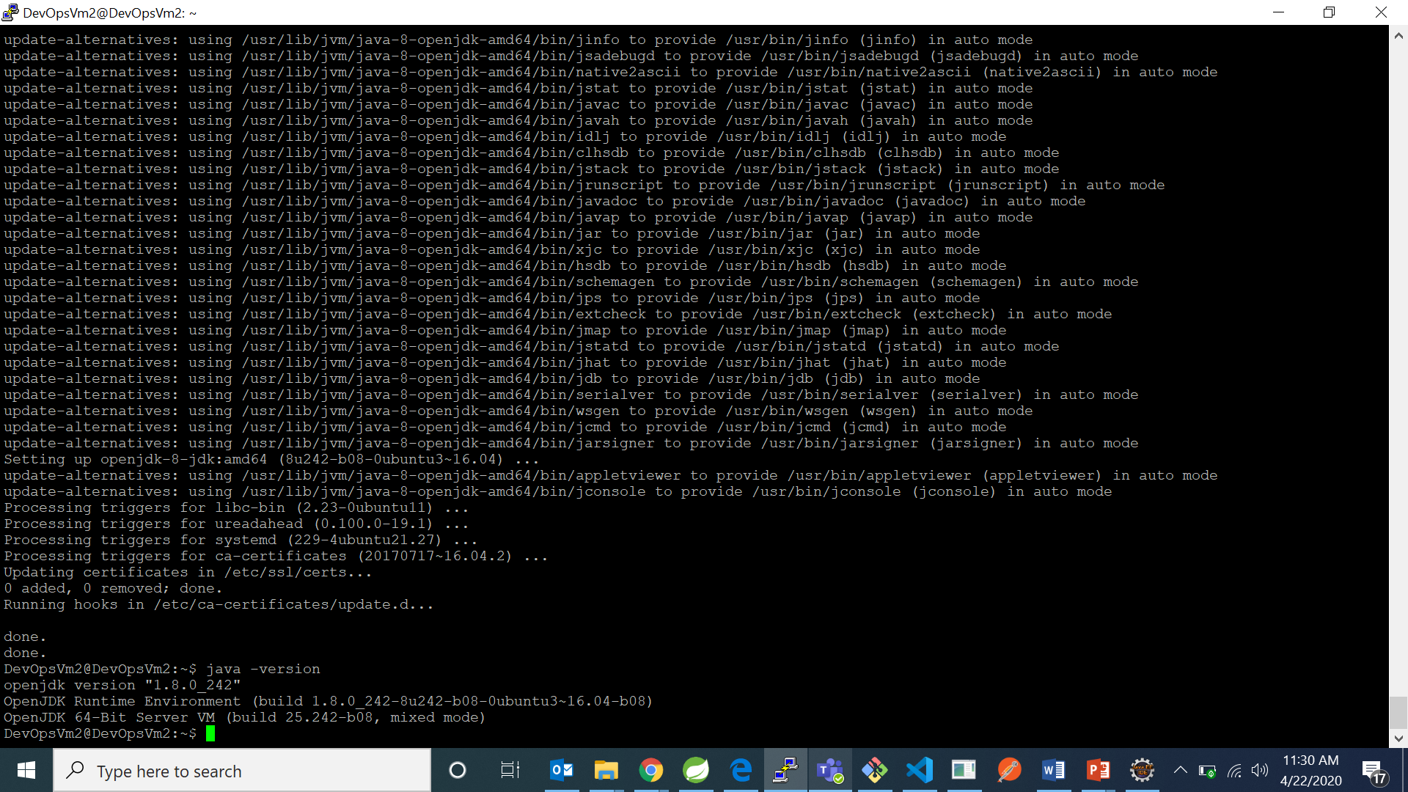

1. Download and Install JFrog Artifactory

The quickest and easiest way to get JFrog installed is via a APT repository. Installing JFrog from the repository will allow you to always get the latest updates

1. Install wget and other packages if you don’t already have them installed by using command “sudo apt install wget software-properties-common”.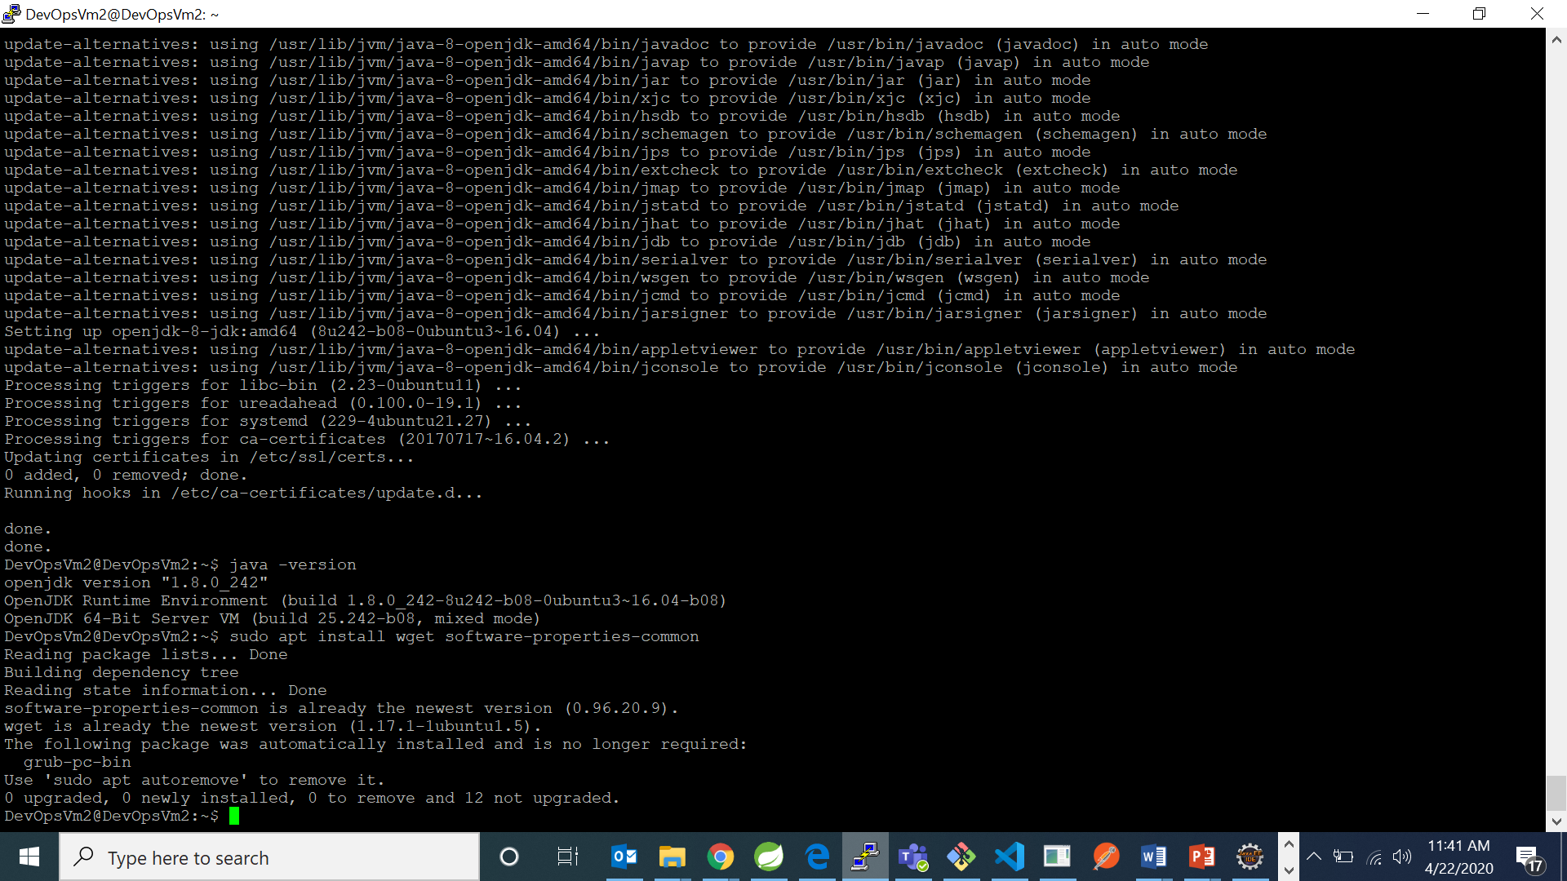

Then run the commands below to add the repository key and file to Ubuntu.

1. wget -qO - https://api.bintray.com/orgs/jfrog/keys/gpg/public.key | apt-key add -

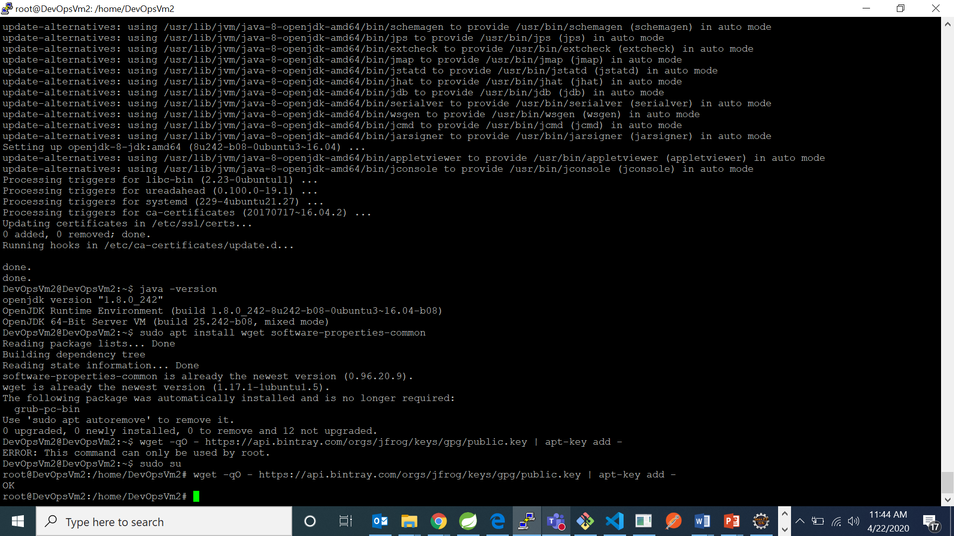

sudo add-apt-repository "deb [arch=amd64] https://jfrog.bintray.com/artifactory-debs $(lsb_release -cs) main"

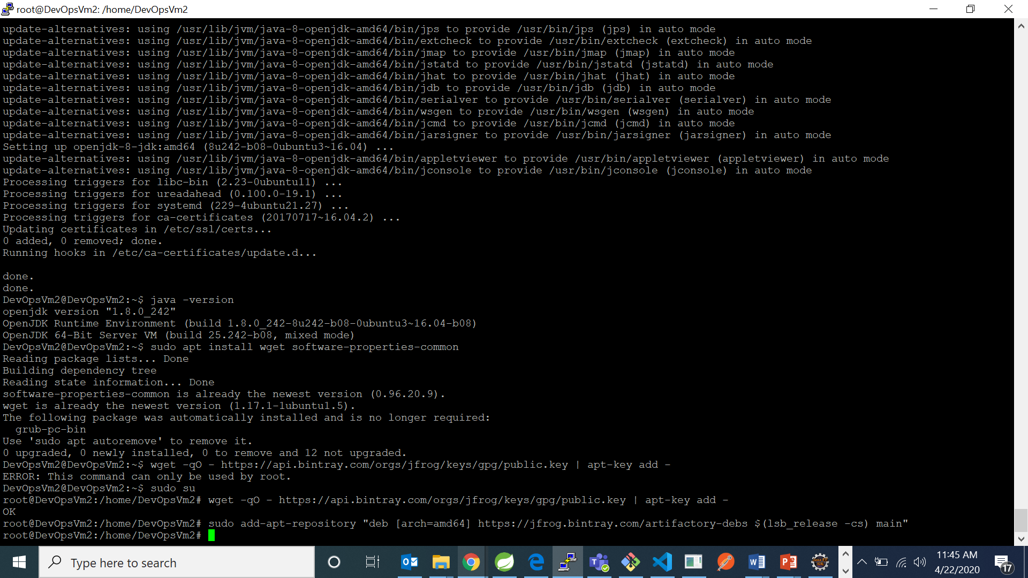

When you’re done, run the commands below to update Ubuntu and install JFrog Artifactory.

1. sudo apt update

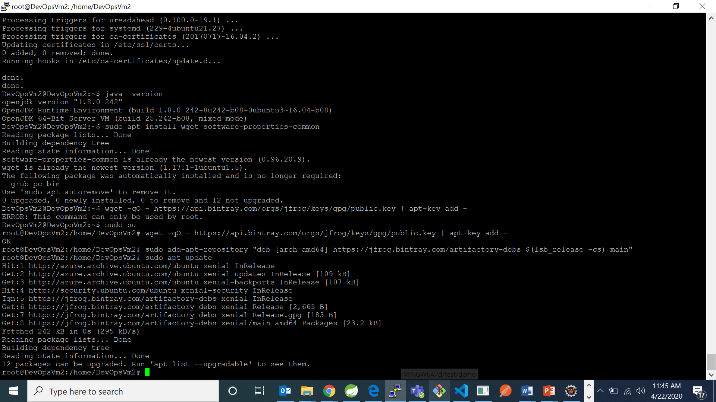

1. sudo apt install jfrog-artifactory-oss

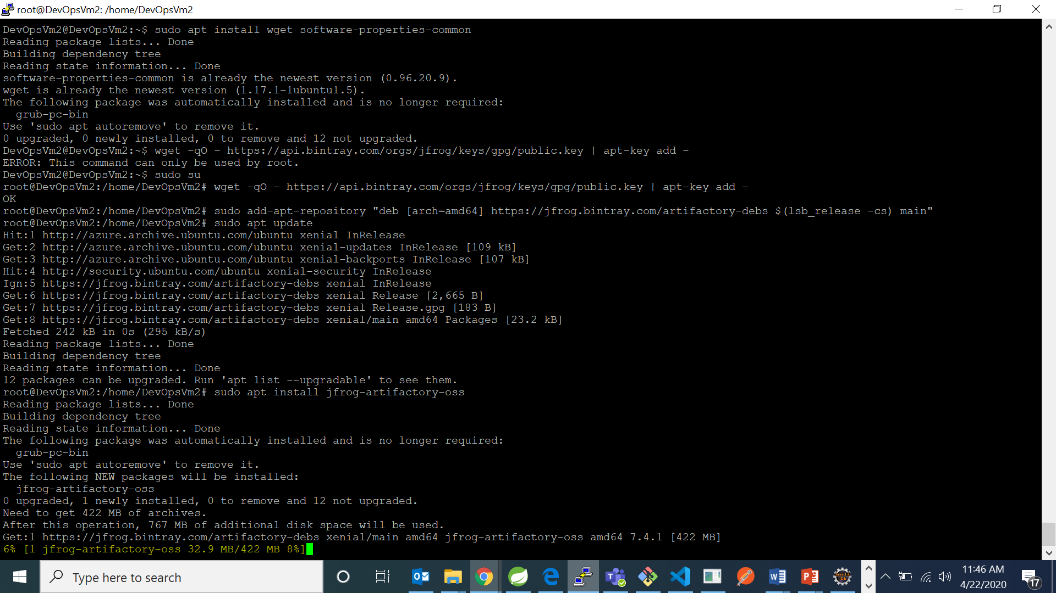

After successful instaltion you can see in the screen:

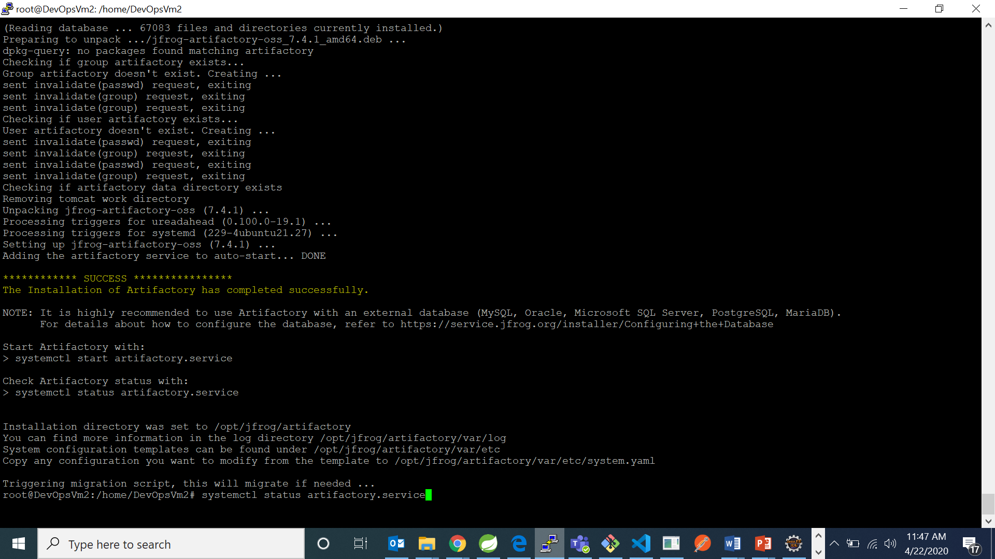

Now start jfrog using the command:

1. systemctl start artifactory.service
2. To check the service status, run the commands below:

systemctl status artifactory.service

